1. 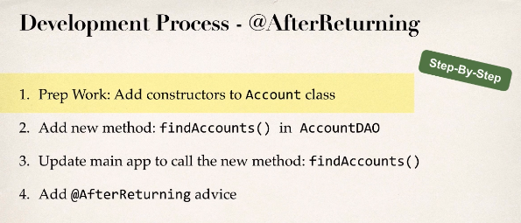
2. Write code yourself from lecture 339.